Michael Osei

5/25/2023

COSC 480

Week 13 Lab

Hosting in Heroku:

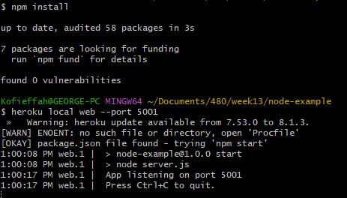

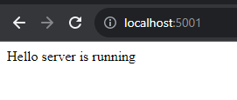

MySQL Server in AWS in EC2

